Ideation Phase
Define the Problem Statements

Date | 31 January 2026
Team ID | LTVIP2026TMIDS71750
Project Name | OrderOnTheGo: Your On-Demand Food Ordering Solution
Maximum Marks | 2 Marks

Customer Problem Statement :
Customers, especially students and working professionals, often struggle to access food conveniently due to busy schedules, late-night hours, and limited food availability. Existing food ordering systems are often complex, time-consuming, and lack transparency in pricing, delivery time, and order status. These issues lead to frustration, uncertainty, and reduced user satisfaction.
There is a need for a unified, user-friendly on-demand food ordering platform that simplifies the ordering process, provides clear food details and pricing, supports secure online payments, and enables real-time order tracking. Such a system should ensure convenience, reliability, and a seamless experience for customers while also supporting restaurants and administrators in managing orders efficiently.

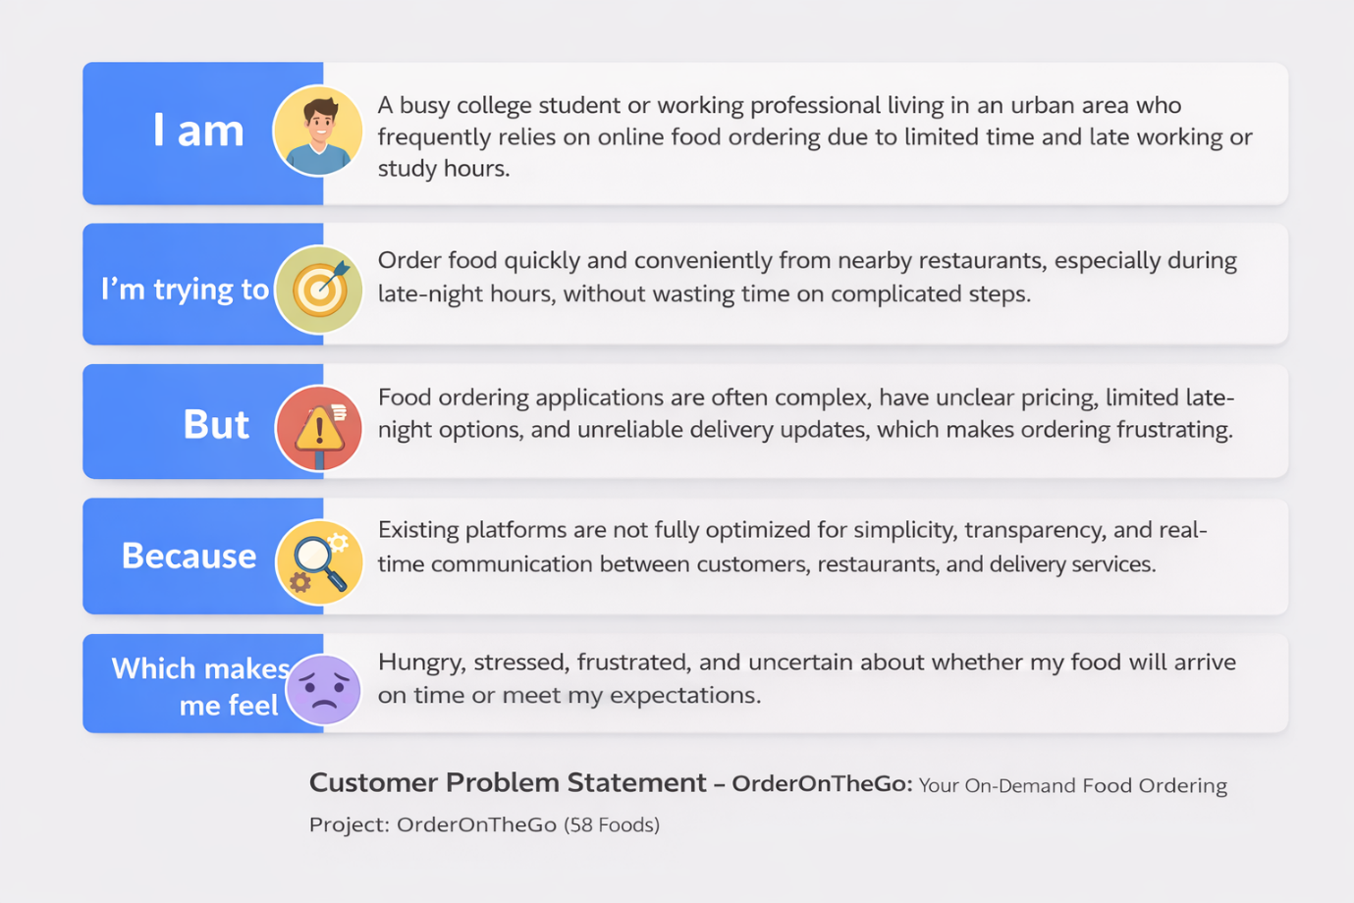

Example:

Problem Statement (PS) |  | I’m trying to | But | Because | Which makes me feel
  I am (Customer)
PS-1 | a busy college student or working professional. | to order food quickly and conveniently from nearby restaurants, especially during late-night hours. | food ordering apps are complex, have unclear pricing, and limited late-night options. | existing platforms are not optimized for simplicity, transparency, and real-time updates. | hungry, frustrated, and uncertain about delivery timing.
PS-2 | a restaurant owner or staff member. | to manage food listings, orders, and customer requests efficiently through an online platform. | managing orders and updates becomes difficult during peak hours. | existing systems lack an integrated and easy-to-use restaurant management dashboard. | stressed and unable to handle orders smoothly.

